

**CSE260**

**PASSWORD SECURITY SYSTEM**

**GROUP - 1**

| **NAME** | **ID** | **THEORY SECTION** |
| --- | --- | --- |
| **Nubayra Rashmin Sikder** | **21101269** | **6** |
| **Anika Islam** | **21101298** | **6** |
| **Jannatul Ferdious Mithila** | **21101302** | **6** |
| **Nusrat Jahan Nuha** | **21141009** | **6** |

**INTRODUCTION :**

In our daily life , the chances of valuables to be robbed have become really common ; if not secured properly . For this reason, there is a dire need for password based lock systems in the doors of our houses and offices , closets , bags , lockers and many more. Moreover, the objective of this project is to come up with the idea of implementing a password security system using logic gates and other simple components , instead of using a microcontroller or arduino.

**PROPOSED MODEL / SYSTEM :**

Our project consists of two parts . First part consists of a switch which allows the user to set the password of the system. On the other hand, the second part consists of another switch where the user or any other has to give the password. The password in the first switch (key code switch) and the password in the second switch (data entry switch) must be the same to allow access. The circuit works like a comparator.

**EXPERIMENTAL SETUP :**

**COMPONENTS USED :**

1. NOR Gate (IC 4001)
2. XOR Gate (IC 4070)
3. 10 kΩ Resistors
4. 470 Ω Resistors
5. 9V Battery
6. LED
7. 1N4148 switching diodes
8. Pushbutton switch
9. 8 position DIP switches
10. Bread board
11. Connecting wires

**CIRCUIT DIAGRAM :**

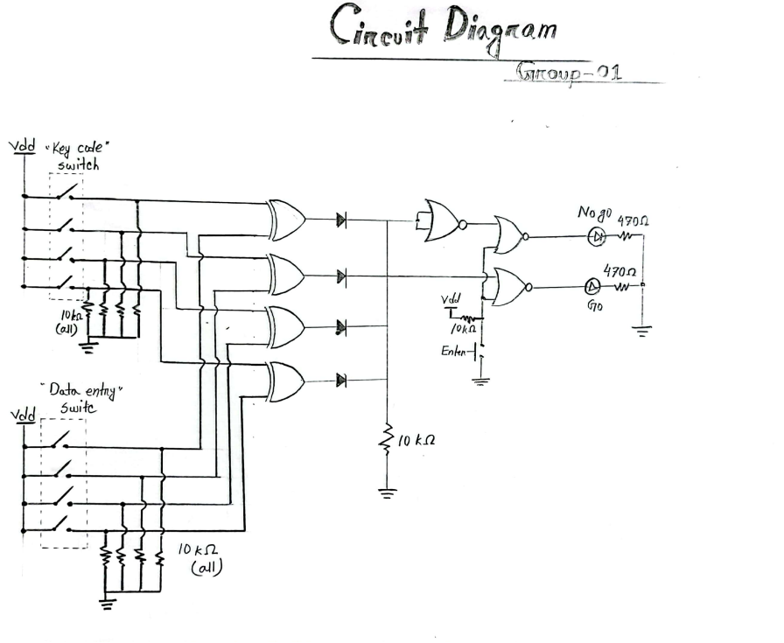

**CIRCUIT :**

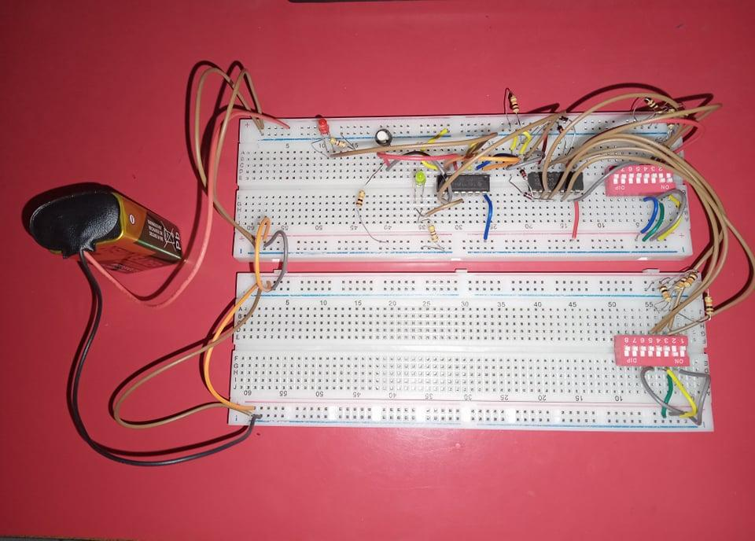

**EXPLANATION :**

The key code switch and the data entry switch are connected to 10 kΩ resistors to reduce the current flow and the resistors are grounded to prevent the damage or short circuit to the circuit caused by excessive voltage. The inputs from the key code switch and the data entry switch are connected to the XOR gates . Afterwards, the outputs of the XOR gates are connected to switching diodes . When voltage increases , the resistance inside the diodes decreases and they are forward biased - making the diode work as an open switch. For the other case, the diodes are reverse biased and act as a closed switch. Moreover, all the diodes are connected in a single line to a 10 kΩ resistor. Two of the outputs of the diodes are connected to NOR gates . The inputs of the first NOR gate are shorted and its output is connected to a second NOR gate. Also, the remaining one input of the 2nd NOR gate is connected to the third NOR gate where there is already another input with the diode. Furthermore, the inputs of the second and third NOR gates are connected in a line and connected to a push switch and 10 kΩ resistor. Also, the output of second NOR gate is connected to Red LED and the third NOR gate to the Green LED , which are then connected to 470 Ω resistor, which are later grounded.

**RESULTS AND ANALYSIS :**

**TRUTH TABLE :**

**XOR Truth Table:**

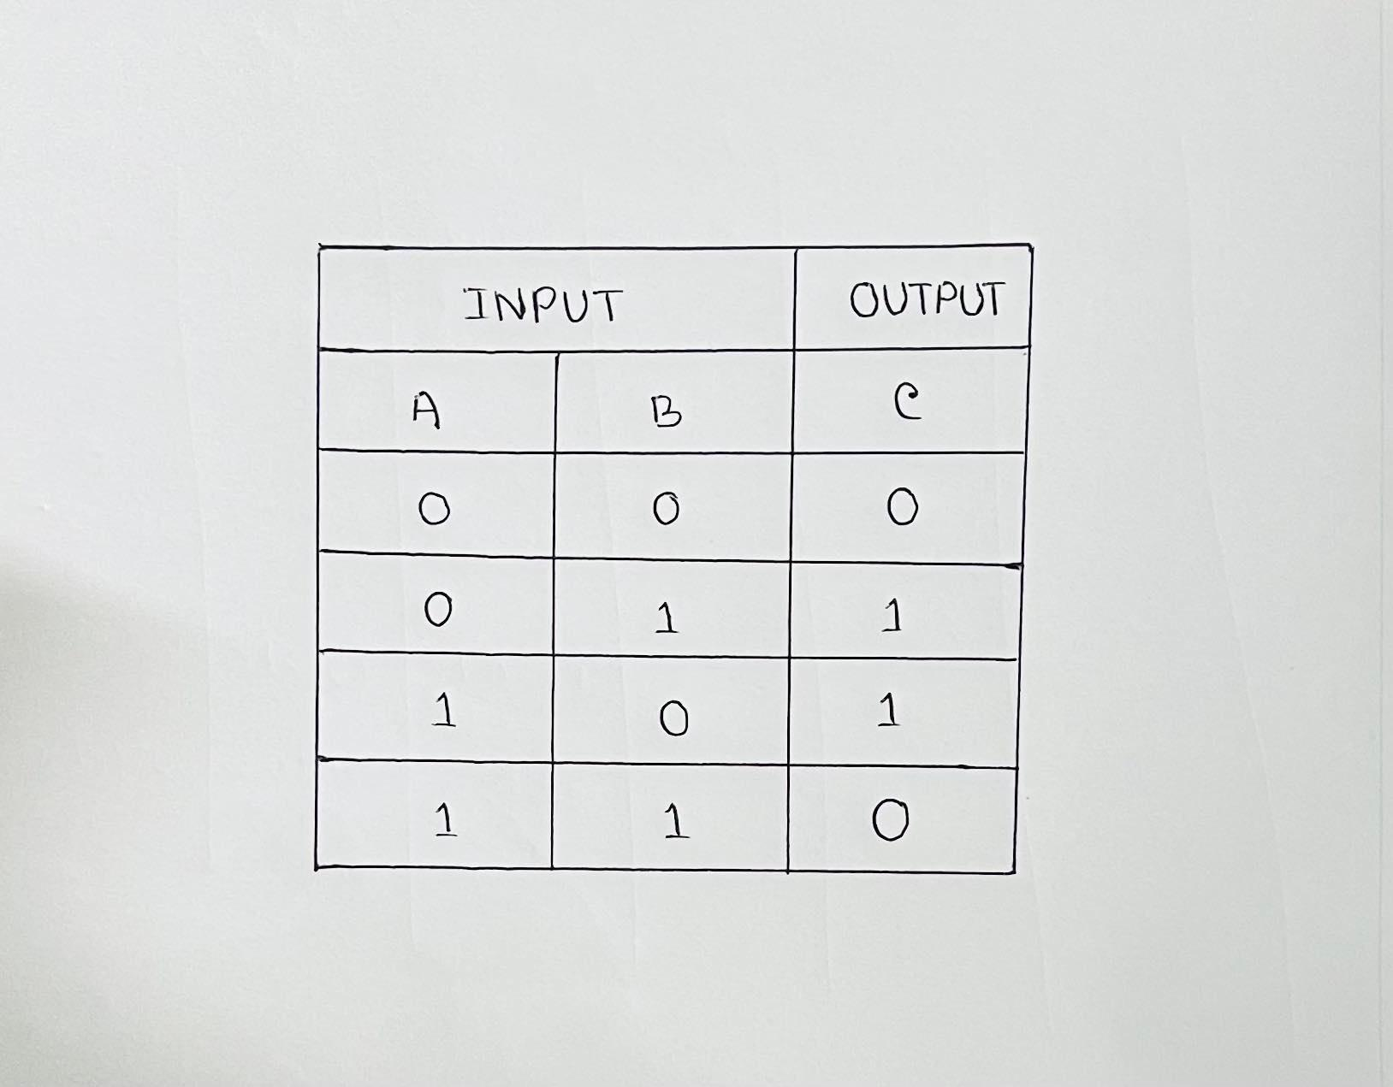

**NOR Truth Table:**

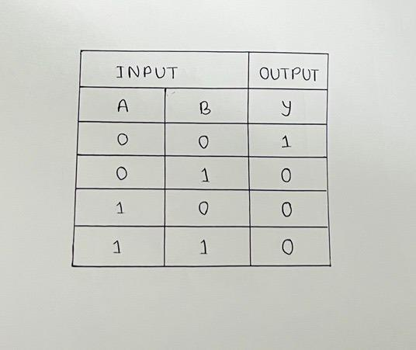

**RESULT SUMMARY :**

As we can see the practical implementation of this paper is given above in Fig 1. Now let us discuss the results or how the system works when we are using it. Initially, we have to set a password in the key code switch, so the password is stored there unless changed by the user . If the password given in the data entry switch matches the fixed password in the key code switch, then only Green LED lights up - indicating the password is correct and allows access. On the other hand, if the password given in the data entry switch does not match the fixed password in the key code switch, then Red LED lights up to inform us that the password is wrong and denies access.

**SHORT EXPLANATION OF RESULT :**

For the Green LED to light up , the NOR gate output connected to the Green LED needs to be 1 and the NOR gate output connected to the Red LED needs to be 0. Thus showing that the password is correct. For the Red LED to light up, the NOR gate output connected to the Red LED needs to be 1 and the NOR gate output connected to the Green LED needs to be 0. As a result, showing that the password is incorrect.

Here is a simplified explanation of the above statement :

Green LED => NOR gate connected to Green LED = 1 AND NOR gate connected to Red LED = 0

Red LED => NOR gate connected to Red LED = 1 AND NOR gate connected to Green LED = 0

**CONCLUSION :**

**LIMITATIONS :**

1. If anyone else apart from the user knows the password, he or she can access the password set in the key code switch . Thus, this circuit does not have the feature to distinguish the real owner.
2. There is no advantaged way to detect the actual owner . For example, it does not have a fingerprint sensor or face recognition.

**CONCLUDING REMARKS :**

This project is productive in providing enough security as long as the password is not shared. In future this “Password Security System” can be provided maximum security by the above enhancements in order to completely satisfy user’s needs. Hence, a common man can afford to buy such a security system at minimal cost to keep his valuables safely without any worries.

**----------------------**